DESIGNING A RESUME CV USING CANVA

INTRODUCTION

1.1Overview:

A resume is an essential tool when looking for a new job. In today’s job market, the resume has become the number one requirement potential employers request. Before an employer will take valuable time to interview you, he or she wants to meet you – on paper. How you impress that employer with your resume can, and will, make all the difference. This article will show you how to create a resume in Canva, that is stylish and accurately conveys your work experience. A resume is an essential tool when looking for a new job. In today’s job market, the resume has become the number one requirement potential employers request. Before an employer will take valuable time to interview you, he or she wants to meet you – on paper. How you impress that employer with your resume can, and will, make all the difference. This article will show you how to create a resume in Canva, that is stylish and accurately conveys your work experience.

appKOPPPPPPpppPPGGpppppppppPPplying for your dream job is easy and fastChoose from hundreds of free, designer-made templates and customize them within a few clicks. Forget spending hours formatting yo. ur resume, or choosing complimentary fonts for your cover letter.

With Canva's free resume builder, applying for your dream job is easy and fast. Choose from hundreds of free, designer-made templates and customize them within a few clicks. Forget spending hours formatting your resume, or choosing complimentary fonts for your canva

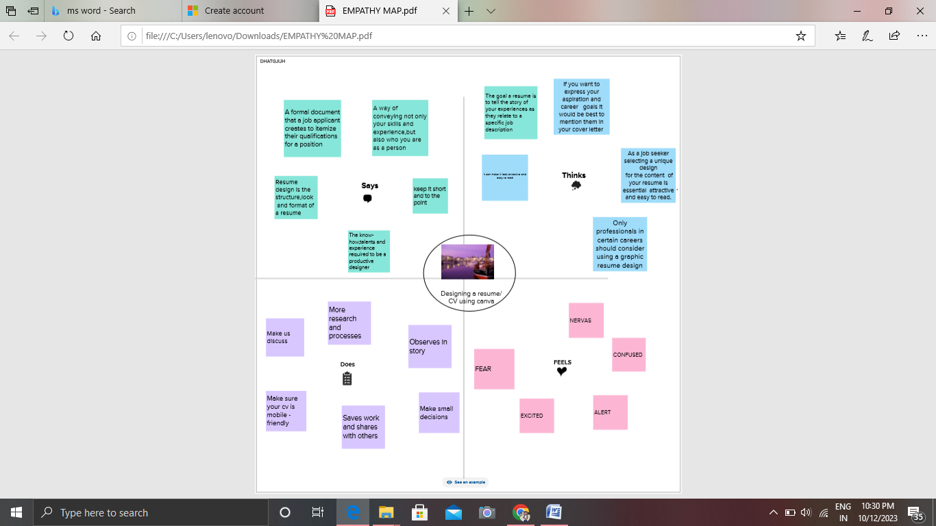

2.2 Brainstorming

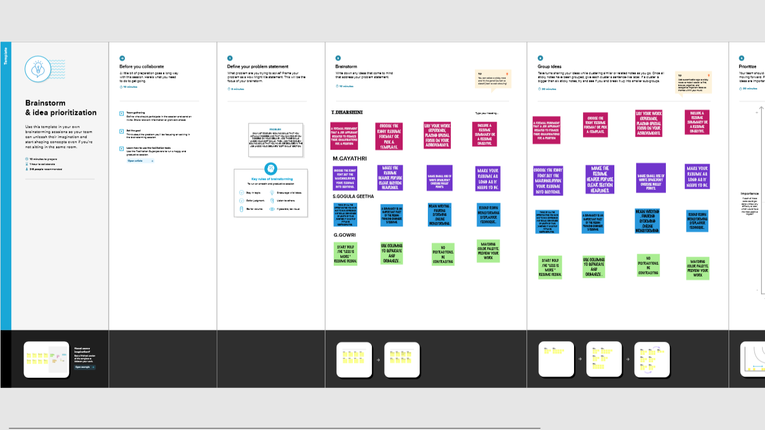

Result:

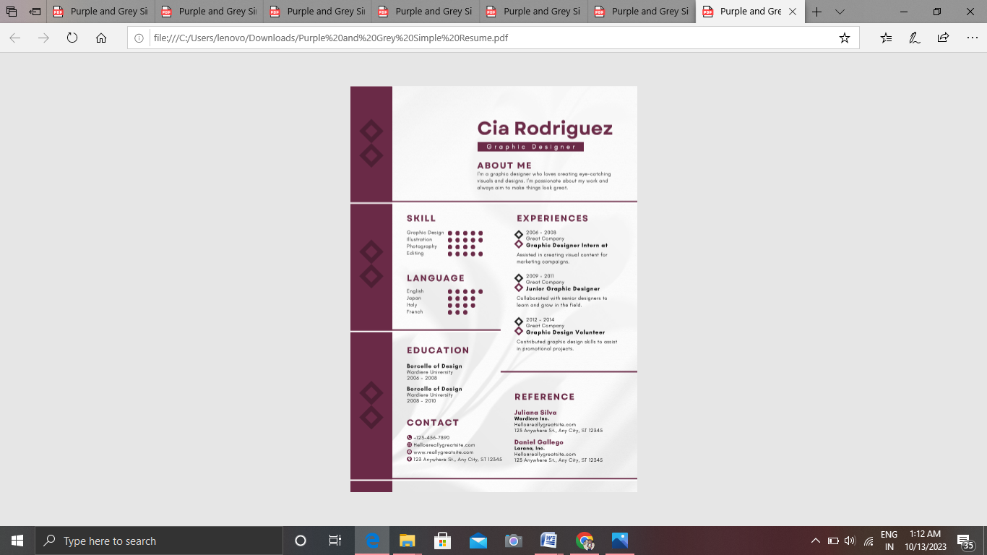

4 ADVANTAGES AND DISADVANTAGES ;

Users will have access to free customizable templates, backgroundimages, styles, and layouts, enough to design a great resume

It is possible to get an idea of someone ,s personality from a cv.

Qualification like drades and schooling are given excessive importance . this enable discrimination based on where people went to university etc, qualities that can also be related to different economic backgrounds.

5.APPLICATION

graphic design cv is a written document that showcases your qualifications for the role you’re applying for ,including skills ,experience and certifications.

6. CONCLUSION

Through this project we learnt to create any types of resume with canva. this project is useful to us to give a good performance in interviews.